

Device Configuration

Jungle Commerce Pty Ltd
ZebraTC25 Scanner

Outlined below is a step-by-step guide on how to configure a ZebraTC25 scanner to be compatible with Jungle.
- Turn on your ZebraTC25 scanner
- Open App "DataWedge"
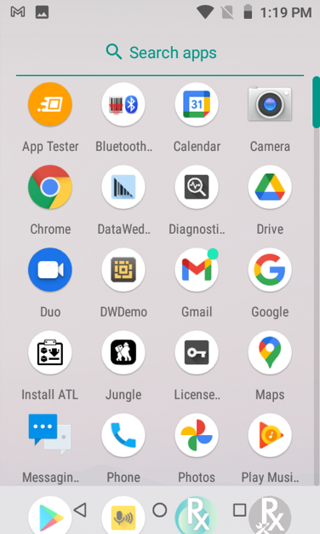
- Click "Profile"
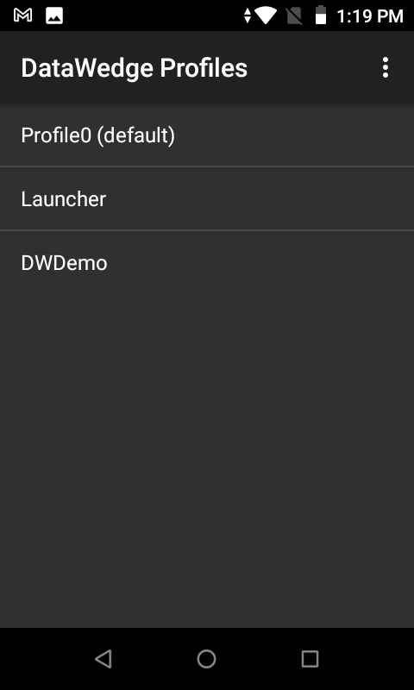

- Scroll down to find "Keystroke output"
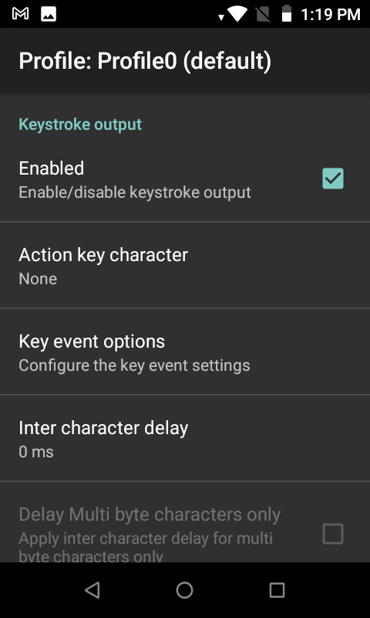
- Click "Key event options"
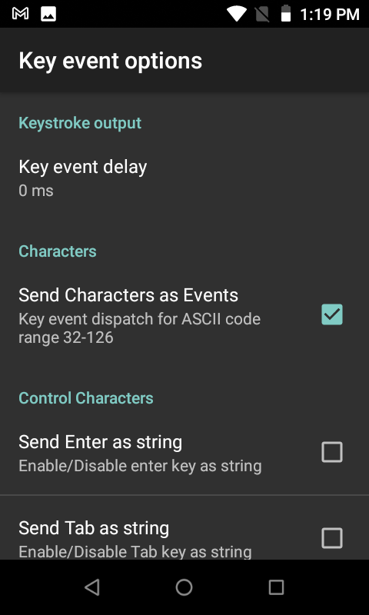
- Under "Characters", enable "Send Characters as Events"
- Your scanner is now configured

